Pre Observation

Fill in the following Table before we begin. Pictures don’t have to be spectacular, but try not to be horrible!

| Newton’s 3 Laws | Picture of the Law |
| --- | --- |
| 1st law: if a body is at rest or moving at a constant speed in a straight line, it will remain at rest or keep moving in a straight line at constant speed unless it is acted upon by a force. | The Physics of Productivity: Newton's Laws of Getting Stuff Done |
| 2nd law: the acceleration of an object is dependent upon two variables - the [net force](http://www.physicsclassroom.com/Class/newtlaws/u2l2d.cfm) acting upon the object and the mass of the object. The acceleration of an object depends directly upon the net force acting upon the object, and inversely upon the mass of the object. | Newton's Laws |
| 3rd law: that for every action (force) in nature there is an equal and opposite reaction. | What is Newton's third law? (article) | Khan Academy |

Newton’s First Law

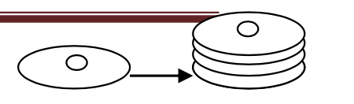

Observation: Penny Stack

Read the directions below and make a prediction on your data sheet before trying it out!

| Prediction | I predict that when 1, 2 and possibly 3 pennies are flicked at the stack of 4 they will move the same amount of pennies away and the one/s not affected will stay in the same position. ( the stacks will affect each other equally) |
| --- | --- |

* To prepare for this experiment, stack 4 pennies one on top of the other so that you form a tower of pennies.
* Place the stack of pennies on top of your textbook or on the floor so that you have a smooth, slick surface.
* Aim one penny at the bottom of the stack of four pennies and give it a good hard flick with your finger or hand. What happens?
* Flick a stack of two pennies into a stack of four pennies. What happens?
* Flick a stack of four pennies into a stack of four pennies. What happens?
* Explain your observations in terms of Newton’s 1st Law. Draw and label a diagram using arrows in your explanation.

| Thought Questions | One penny, the bottom penny shows significant movement the others move as well but that is most likely because the force applies was not enough  Two pennies Same reaction- bottom two moved- more movement with all pennies  Three pennies - same but even more movement from the presumably still pennie  Four- moved the whole other stack |
| --- | --- |
| Conclusion and Explanations | This demonstrates Newton's 1st law because when a certain number of pennies are flicked they only affect the penny/pennies they come in contact with and the other pennies stay at rest and do not move. The force is only being applied to one penny so it will move and the others will stay at rest. |

Observation Activity: Magician’s Trick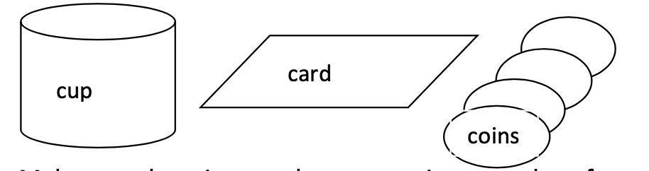

Read the directions below and make a prediction on your data sheet before trying it out.

| Prediction | I predict that the coin will fall in the approximate same place into the cup as it was previously. And as more coins are added some might be ficked/ moved with the card bt the top layer will fall in the same place. |
| --- | --- |

You will need the following:

* Note Card
* Cup
* 4 Pennies
* Place the card on top of the cup. Make sure there is enough space to give one edge of the card a good flick without smacking your finger into the side of the cup.
* Place a single coin on top of the card so that it rests over the cup's opening.  
  Flick an exposed edge of the note card. Don't flick the card from underneath. Flick directly from the side of the card's edge.
* Observe what happens to the coin. Explain what happened.  
  Repeat steps 1-4, add pennies to each trial, and explain what happens when pennies are added.
* How does this activity relate to the “pull the tablecloth” trick used by magicians?  
  How does this activity relate to Newton’s 1st Law?

| Thought Questions | One penny- falls in the cup  So do the rest as number increases but as more pennies are added add the mass increases it takes a harder flick |
| --- | --- |
| Conclusion and Explanations | This demonstrates how force mass and acceleration relate to each other the harder you flick the card the more likely the pennies are to fall the the more pennies(mass) the more force is required to make them fall but the faster (more acceleration) they have when falling. |

Newton’s Third Law

Observation Station: Penny Slide

If two pennies collide with a group of 3 pennies as in the diagram below, predict the results of the collision.

| Prediction | I predict that when the pennies collide the same amount of pennies will be affected when the two hit the two on the other side will move. ( note this will only happen if both lines are perfectly straight) |
| --- | --- |

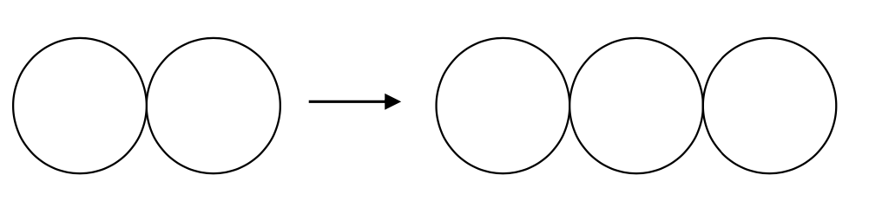

Procedures:

* Obtain 5 coins (pennies, washers, checkers, etc. will also work)
* Line up 3 pennies touching in a perfect line.
* Line up 2 more pennies touching each other in perfect line with the other 3 pennies. There should be a 5 cm gap between the groups of pennies.
* Place your fingers onto the two slider pennies. Slide the two pennies into the group of 3 pennies. Be sure that the two slider pennies stay in contact with each other when they collide with the group of 3. This may take practice to slide them correctly.
* Record what happens to the groups of pennies after collision. (Repeat several times for best results.)
* Repeat the collision several more times with different combinations of sliders. 7. Record your observations.

| Thought Questions | The reaction was congruent with my prediction and when the two pennies hit the three the opposite 2 moved and the middle was not affected much |
| --- | --- |
| Conclusion and Explanations | Proved by newton's 3rd law the force applied to the three pennies by the two would not be equal if all the other moved but since every force has an equal and opposite reaction the force travels through the line and affect the two at the end. |

Discovery Station: Newton’s Cradle 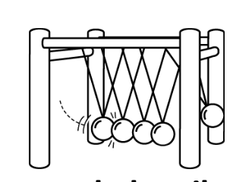

Prediction: Predict what would happen when one marble is pulled away from the rest of the marbles and allowed to swing down to collide with the other marbles.

| Prediction | I predict that when the marbles collide the same amount of marbles will be affected when the two hit the two on the other side will move. ex. |
| --- | --- |

Procedures:

* Using the thumb and index finger, grab a marble on the end and pull it away from the rest of the marbles. Release the marble.
* Explain what happened?
* Repeat step 2 with different combinations.
* Record your observations.
* Explain how Newton’s Cradle demonstrates Newton’s Third Law of Motion.

| Thought Questions | This is much like the last experiment except the force is not diminished after one use and it reacted as my observations and predictions stated. But the force is contained for a much longer time and the bounce) getts smaller as less force is applied |
| --- | --- |
| Conclusion and Explanations | My previous conclusion and observation apply to this as well the mail difference being there is less movement of the other (pennies/marbles) because the force is more circular. Are it Reuters back to the main contraction instead of being released. And when you do two to the sides ( the marbles at each end) they seemed to bounce of each other's force( energy) so when there are 2 on a side and 1 on the other the amount of marbles transition to the other side, demonstrating how the force is transitioning |